How would we solve the problem?

The problem inherently is data intensive. The problem can be broken down in to three smaller problems which can be solved independently but at a higher level should perform data sharing in order to get results at a better level. This problem can be solved with data modelling and data analysis methods at one level and deep learning at other level. The problem set is:

1. Capturing a Wish
   1. Better data capturing methods
   2. Reduce cost of capturing data
   3. Automate the process of data
2. Reduce Cost of Wish Analysis
   1. Better way to conduct interviews
   2. Reduce the need for interviews
   3. Find all potential risks
3. Reduce the ‘Degrees of Separation’
   1. Locate/Find the right donors
   2. Disseminate right information
   3. Find possible contacts to the donors
   4. Create a relationship map between the donor and Organization

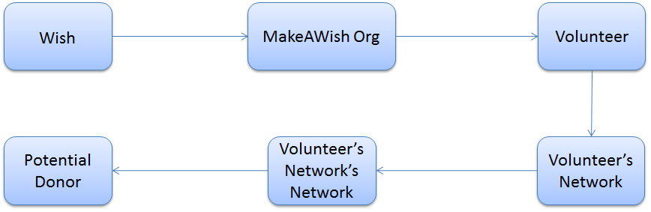

Figure 1: The concept map of six degree of separation as per our understanding

In a broader sense, the problem can be solved through a detailed analysis of data to find the right keywords. It can be done by using the semantic based topic models or better data learning methods. Let’s have a look at each problem separately.

1. Capturing a Wish

This is the first step in Make a Wish agenda. It is crucial to capture the wish properly. For that, we need to implement a conceptual model for wish data that is received through the online portal. More information captured can mean more insight into child’s condition and hence better estimate of the timeline.

* 1. Better data capturing methods:
  2. Reduce cost of capturing data:
  3. Automate the process of data

1. Reduce Cost of Wish Analysis
   1. Better way to conduct interviews: Video Conferencing to speak to child about a particular wish, this would eliminate the problem of making the video for wish capturing. This could be a good way of reducing cost of making marketing videos.
   2. Reduce the need for interviews: Maybe by formulating the questions in a more detailed manner and reducing the chance of ambiguous answers. Intentions can be verified by online interviews
2. Tracking the Wish
   1. Define stages of the wish capturing process (Assuming the stages have already been abstractly defined). The stages can have 4 to 5 levels starting from making the wish, analysing the wish, granting the wish, etc.
   2. Break down the main stages into sub-stages and assign the stage to each task so that the progress can be monitored. Break down will be a better method of measuring the progress in a quantitative manner. Combination of quantitative variables like deadline (for time sensitive tasks) priority and progress can help prioritizing the tasks in better way and potentially reduce the amount of time consumed for a volunteer (or a Wish Granter) to get the job done. It can save the precious time hence reducing the cost.
3. Reduce the ‘Degrees of Separation’
   1. Locate/Find the right donors: Graph models and Deep Networks can be used to get information from public APIs of social media handlers (they provide the publically available data sometimes for free). This would help find the connection to the donor. This could help a lot in getting more volunteers and maybe one-time volunteers.
   2. Disseminate right information: Based on each person’s profession, they have certain set of skills, but this can be expanded into finding the people with hobbies which teach them right skills for a task that we need.
   3. Find possible contacts to the donors: Who would know the right person? Reaching out to a network of network rather than one volunteer’s network.
   4. Create a relationship map between the donor and Organization: Know who in your network have which contacts.